

SAVEETHA INSTITUTE OF MEDICAL AND TECHNICAL SCIENCES
SAVEETHA SCHOOL OF ENGINEERING

CS023 COMPILER DESIGN LAB MANUAL

B.E. COMPUTER SCIENCE AND ENGINEERING

VII SEMESTER (R-2016)
IV YEAR

2019-2020-ODD SEMESTER

COURSE OBJECTIVES

The course aims are:
  - To introduce the major concept areas of language translation and compiler design.
  - To enrich the knowledge in various phases of compiler ant its use, code optimization
techniques, machine code generation, and use of symbol table.
  - To extend the knowledge of parser by parsing LL parser and LR parser.
  - To provide practical programming skills necessary for constructing a compiler.

COURSE OUTCOMES

- To use the knowledge of patterns, tokens & regular expressions for solving a problems.
- To apply the knowledge of lex tool & yacc tool to develop a scanner & parser.
- To learn the new code optimization techniques to improve the performance of a program in terms of speed & space.
- To design & implement a software system for backend of the compiler.
- To acquire the knowledge of modern compiler & its features.

SNO | LIST OF EXPERIMENTS | PAGE NO
1. | Write a C program to create a Symbol Table and perform insert, search and modify operations. | 3
2. | Write a C program to develop a lexical analyzer to recognize a few patterns, identifiers, constants and comments. | 6
3. | Write a program to implement the function of Lexical Analyzer using Lex Tool. | 12
4. | Write a Program to implement calculator using LEX and YAAC | 14
5. | Write a C program to implement Predictive Parser table. | 18
6. | Write a C program to implement Recursive Descent Parsing. | 25
7. | Write a program to implement the concept of type checking. | 28
8. | Write a program to construct DAG. | 32
9. | Write a program to implement back-end process of a compiler. | 35
10. | Write a program to implement any one Code Optimization Techniques. | 38
ADDITIONAL EXPERIMENTS
11. | Implement the front end of a compiler | 40
12. | Implement Shift Reduce Parser | 43

EXP NO: 1 IMPLEMENTATION OF SYMBOL TABLE USING C

AIM
The objective of the C program is to implement Symbol Table with functions to create, insert, modify, search, and display.
ALGORITHM
STEP 1: Start the program for performing insert, display, delete, search and modify option in symbol table STEP 2: Define the structure of the Symbol Table
STEP 3: Enter the choice for performing the operations in the symbol Table
STEP 4: If the entered choice is 1, search the symbol table for the symbol to be inserted. If the symbol is already present, it displays "Duplicate Symbol". Else, insert the symbol and the corresponding address in the symbol table.
STEP 5: If the entered choice is 2, the symbols present in the symbol table are displayed.
STEP 6: If the entered choice is 3, the symbol is searched in the symbol table. If it is not found in the symbol table it displays "Label Not found".
STEP 7: If the entered choice is 4, the symbol to be modified is searched in the symbol table. The address of the label can be modified.
STEP 8: Enter choice 5 to exit the program.
PROGRAM
#include<stdio.h>
#include<ctype.h>
#include<stdlib.h>
#include<string.h>
#include<math.h>
void main()
{
int i=0,j=0,x=0,n;
void *p,*add[5];
char ch,srch,b[15],d[15],c;
printf("Expression terminated by $:");
while((c=getchar())!='$')
{
b[i]=c;
i++;
}
n=i-1;
printf("Given Expression:");
i=0;
while(i<=n)
{
printf("%c",b[i]);
i++;
}
printf("\n Symbol Table\n");
printf("Symbol \t addr \t type");
while(j<=n)
{
c=b[j];
if(isalpha(toascii(c)))
{
p=malloc(c);
add[x]=p;
d[x]=c;
printf("\n%c \t %d \t identifier\n",c,p);
x++;
j++;
}
else
{
ch=c;
if(ch=='+'||ch=='-'||ch=='*'||ch=='=')
{
p=malloc(ch);
add[x]=p;
d[x]=ch;
printf("\n %c \t %d \t operator\n",ch,p);
x++;
j++;
}
}
}
}

OUTPUT:
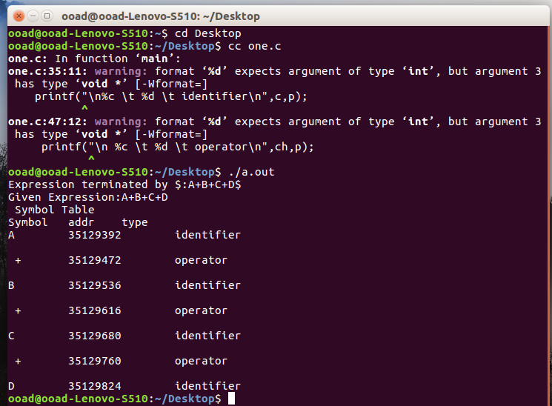

RESULT:

Thus the Program is executed and verified successfully.

EXP NO 2: LEXICAL ANALYZER TO RECOGNIZE FEW PATTERNS IN C
AIM
To Write a program for implementing Lexical Analyzer in ‘C’ (ex. identifiers, constants, comments, operators etc.)
ALGORITHM
STEP 1: Create files for storing, keywords, Operators and a program as an input.
STEP 2: Read the source file as input.
STEP 3: Scan the first character
STEP 4: Check the character begin with alphabet or digit using the functions isalpha() and isdigit().
STEP 5: If isdigit() returns true then print it as a constant.
STEP 6:If isalpha() returns true check it with keyword file content . If anyone the keyword matches then print it as keyword otherwise print it as an identifier
PROGRAM
#include<stdio.h>
#include<conio.h>
#include<string.h>
#include<ctype.h>
int main()
{
FILE *fsur,*fkey,*fopr;
char c,str[20],ky[20],op[20],temp[20];
int i,set=0;
fsur=fopen("source.txt","r");
fkey=fopen("keyword.txt","r");
fopr=fopen("operator.txt","r");
while(feof(fsur)==0)
{
c=fgetc(fsur);
//Keywords and Identifiers
if(isalpha(c))
{
for(i=0;(isalpha(c))||(isdigit(c))||(c=='_');i++)
{
str[i]=c;
c=fgetc(fsur);
}
str[i]='\0';
rewind(fkey);
while(feof(fkey)==0)
{
fscanf(fkey,"%s",ky);
if(strcmp(ky,str)==0)
{
printf("\n%s is a keyword",str);
set=1;
break;
}
}
if(set==0)
printf("\n%s is an identifier",str);
set=0;
}
//Numeric literals
if(isdigit(c))
{
for(i=0;(isdigit(c))||(c=='.');i++)
{
str[i]=c;
c=fgetc(fsur);
}
str[i]='\0';
printf("\n%s is a numeric literal",str);
}
//String literals
if(c=='\"')
{
c=fgetc(fsur);
for(i=0;c!='\"';i++)
{
str[i]=c;
c=fgetc(fsur);
}
str[i]='\0';
printf("\n\"%s\" is a string literal",str);
}
//Character literal
if(c=='\'')
{
c=fgetc(fsur);
if(c=='\\')
{
c=fgetc(fsur);
printf("\n\\%c is a character literal",c);
}
else
printf("\n%c is a character literal",c);
if((c=fgetc(fsur))!='\'')
printf("\nInvalid character literal");
}
//Preprocessor
if(c=='#')
{
printf("\n%c is a preprocessor symbol",c);
}
//Brackets
if(c=='('||c=='{')
printf("\n%c is an opening braces",c);
if(c==')'||c=='}')
printf("\n%c is a closing braces",c);
//Punctuation symbols
if(c==',')
printf("\n%c is a puntuation",c);
if(c==';')
printf("\n%c is end of statement",c);
//comment lines
if(c=='/')
{
printf("\ncomment lines\n");
c=fgetc(fsur);
if(c=='/')
{
while(c!='\n')
{
c=fgetc(fsur);
printf("%c",c);
}
}
else if(c=='*')
{
for(;;)
{
c=fgetc(fsur);
if(c=='*')
{
c=fgetc(fsur);
if(c=='/') break;
}
printf("%c",c);
}
c=getc(fsur);
}
}
//operators
rewind(fopr);
temp[0]=c;
temp[1]='\0';
while(feof(fopr)==0)
{
fscanf(fopr,"%s",op);
if(strcmp(op,temp)==0)
{
c=fgetc(fsur);
temp[1]=c;
temp[2]='\0';
rewind(fopr);
while(feof(fopr)==0)
{
fscanf(fopr,"%s",op);
if(strcmp(op,temp)==0)
{
printf("\n%s is an operator",temp);
set=1;
break;
}
}
if(set==0)
{
printf("\n%c is an operator",temp[0]);
ungetc(c,fsur);
break;
}
}
}
set=0;
}
getch();
return 0;
}
INPUT
SOURCE.TXT
// demo program
# define N 30
int main()
{
float a = 61.37;
char str1 = ‘s’;
printf(“%c”, str1);
return 0;
}
KEYWORD.TXT
define
int
main
float
char
printf
return
if
while
for
OPERATOR.TXT
+
-
*
/
=
%
==
>
<
>=
<=

OUTPUT:

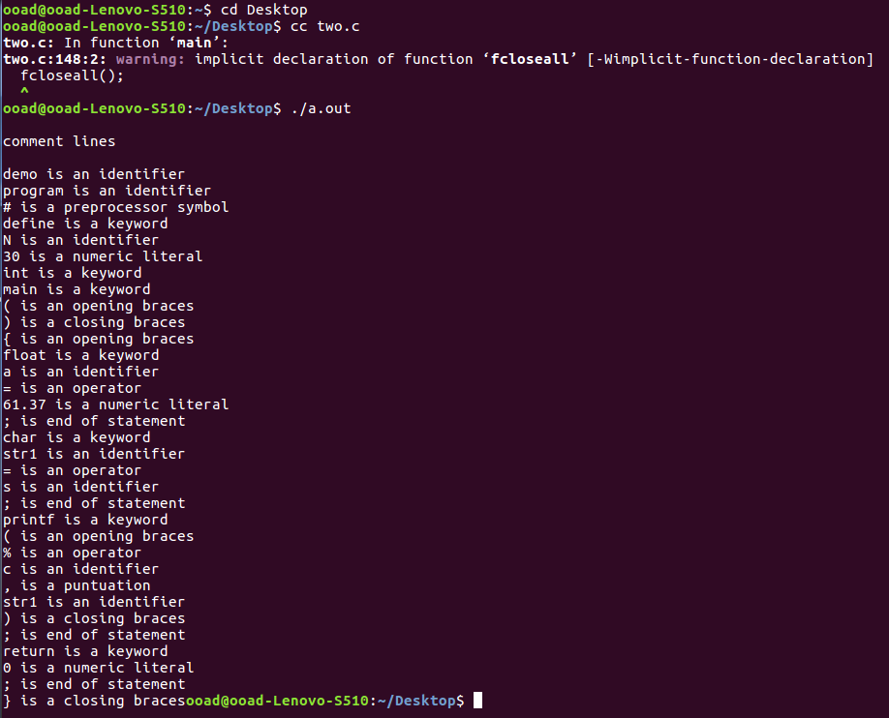
RESULT:

Thus the Program is executed and verified successfully.

EXP NO 3: IMPLEMENTATION OF LEXICAL ANALYZER USING LEX TOOL
AIM
To Write a Program to implement the Lexical Analyzer using LEX Tool.
ALGORITHM
STEP 1:Define and include necessary declarations and Regular definitions
STEP 2: Define the Translation Rule section for Keywords, Identifiers, Constants, Operators and Literal Strings
STEP 3: Read the input from a file.
STEP 4:Lex tool will compare the input with patterns defined under Translation rule section
STEP 5:If any of the pattern matches with the input respective action will be performed.
STEP 6: End.
PROGRAM

%{
#include<math.h>
%}
digit [0-9]
id [A-Za-z][A-Za-z0-9]*
li["]
%%
void|main|int|printf {printf("\nA keyword:%s\n",yytext);}
{digit}+ { printf("\nAn integer:%s(%d)\n",yytext,atoi(yytext));}
{digit}+"."{digit}* {printf("\nA float: %s (%g)\n",yytext,atof(yytext));}
{id} {printf("\nAn identifier:%s\n",yytext);}
"+"|"-"|"*"|"/"|"=" {printf("\nAn operator:%s\n",yytext);}
";"|"("|")"|":"|","|"}"|"{" {printf("\n%s is a punctuation\n",yytext);}
#{id}"<"{id}"."{id}">" {printf("\n%s is a preprocessor\n",yytext);}
{li}"%"{id}+{li} {printf("\n%s is a literal string\n",yytext);}
{li}{id}+{li} {printf("\n%s is a literal string\n",yytext);}
%%
int main()
{
yyin=fopen("sha.c","r");
yylex();
}
int yywrap()
{
return 0;
}

OUTPUT:

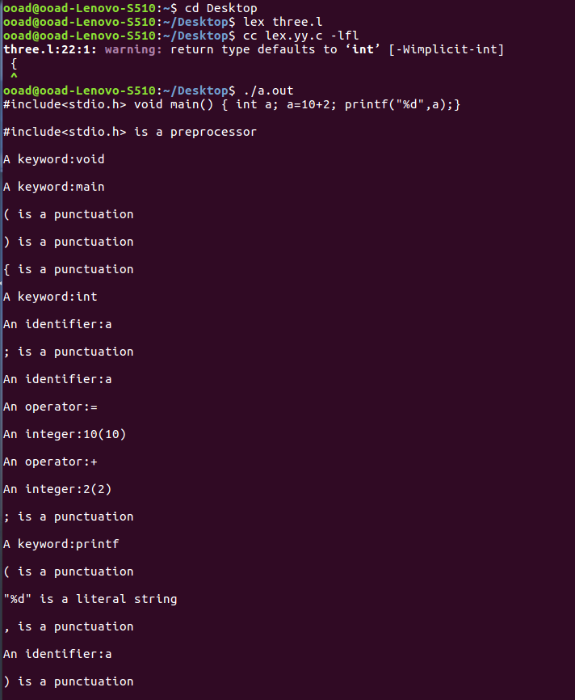

RESULT:

Thus the Program is executed and verified successfully.

EXP NO 4 : IMPLEMENTATION OF CALCULATOR USING LEX AND YAAC
AIM
To write a program to implement scientific calculator using LEX and YACC.
ALGORITHM

For Lex Program sample.l

STEP 1:Include the necessary library files for token definitions and ‘C’ declarations
STEP 2: Define the rules for regular definitions and patterns
STEP 3: Define the functions invoked in the translation rules

For Yacc Program sample.y

STEP 1 : Include the necessary declarations for yacc specifications and ‘C’ headers
STEP 2: Define the translation rules and the input structure specifications for the grammar rules
STEP 3:Define the functions that are invoked in the rules
STEP 4:Read the input
STEP 5: If the given input matches with the defined rules , the yacc tool executes the respective actions.
STEP 6: End.

PROGRAM

LEX PROGRAM
%{
#include <math.h>
%}

DIGIT [0-9]+\.?|[0-9]*\.[0-%{
#include<ctype.h>
#include<stdio.h>
#include <math.h>
#define YYSTYPE double
%}
%token NUM
%token COS SIN TAN LOG
%left '+' '-'
%left '*' '/'
%right UMINUS
%%

S : S E '\n' { printf("Answer: %g \nEnter:\n", $2); }
| S '\n'
|
| error '\n' { yyerror("Error: Enter once more...\n" );yyerrok; }
;
E : E '+' E { $$ = $1 + $3; }
| E'-'E { $$=$1-$3; }
| E'*'E { $$=$1*$3; }
|E'/'E { $$=$1/$3; }
| '('E')' { $$=$2; }
| '-'E %prec UMINUS { $$= -$2; }
| NUM
| COS'('E')' {$$=cos($3);}
| SIN'('E')' {$$=sin($3);}
| TAN'('E')' {$$=tan($3);}
| LOG'('E')' {$$=log($3);}
;

%%

#include "lex.yy.c"
int main()
{
printf("Enter the expression: ");
yyparse();
}
9]+
%%
{DIGIT} {yylval=atof(yytext);return NUM;}
cos|COS {return COS;}
sin|SIN {return SIN;}
tan|TAN {return TAN;}
log|LOG {return LOG;}
\n|. {return yytext[0];}

YAAC PROGRAM
%{
#include<ctype.h>
#include<stdio.h>
#include <math.h>
#define YYSTYPE double
%}
%token NUM
%token COS SIN TAN LOG
%left '+' '-'
%left '*' '/'
%right UMINUS
%%
S : S E '\n' { printf("Answer: %g \nEnter:\n", $2); }
| S '\n'
|
| error '\n' { yyerror("Error: Enter once more...\n" );yyerrok; }
;
E : E '+' E { $$ = $1 + $3; }
| E'-'E { $$=$1-$3; }
| E'*'E { $$=$1*$3; }
|E'/'E { $$=$1/$3; }
| '('E')' { $$=$2; }
| '-'E %prec UMINUS { $$= -$2; }
| NUM
| COS'('E')' {$$=cos($3);}
| SIN'('E')' {$$=sin($3);}
| TAN'('E')' {$$=tan($3);}
| LOG'('E')' {$$=log($3);}
;
%%
#include "lex.yy.c"
int main()
{
printf("Enter the expression: ");
yyparse();
}
OUTPUT:

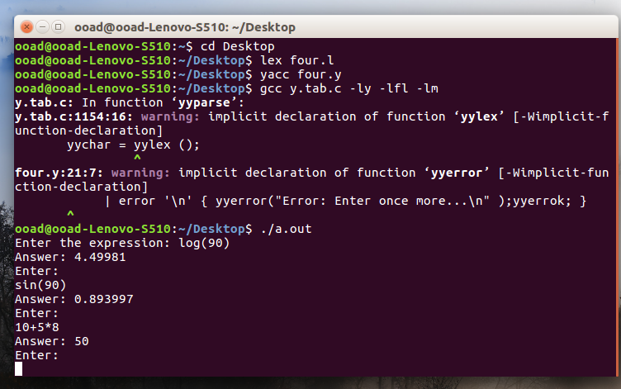

RESULT:

Thus the Program is executed and verified successfully.

EXP NO 5: IMPLEMENTATION OF PREDICTIVE PARSER TABLE USING C
AIM:
To implement the Predictive Parser using C
ALGORITHM:
STEP 1: Read the input string.
STEP 2: By using the FIRST AND FOLLOW values.
STEP 3: Verify the FIRST of non terminal and insert the production in the FIRST value
STEP 4: If we have any @ terms in FIRST then insert the productions in FOLLOW values
STEP 5: Construct the predictive parser table
PROGRAM:
#include<stdio.h>
#include<conio.h>
#include<string.h>
void main()
{
char fin[10][20],st[10][20],ft[20][20],fol[20][20];
int a=0,e,i,t,b,c,n,k,l=0,j,s,m,p;
clrscr();
printf("enter the no. of coordinates\n");
scanf("%d",&n);
printf("enter the productions in a grammar\n");
for(i=0;i<n;i++)
scanf("%s",st[i]);
for(i=0;i<n;i++)
fol[i][0]='\0';
for(s=0;s<n;s++)
{
for(i=0;i<n;i++)
{
j=3;
l=0;
a=0;
l1:if(!((st[i][j]>64)&&(st[i][j]<91)))
{
for(m=0;m<l;m++)
{
if(ft[i][m]==st[i][j])
goto s1;
}
ft[i][l]=st[i][j];
l=l+1;
s1:j=j+1;
}
else
{
if(s>0)
{
while(st[i][j]!=st[a][0])
{
a++;
}
b=0;
while(ft[a][b]!='\0')
{
for(m=0;m<l;m++)
{
if(ft[i][m]==ft[a][b])
goto s2;
}
ft[i][l]=ft[a][b];
l=l+1;
s2:b=b+1;
}
}
}
while(st[i][j]!='\0')
{
if(st[i][j]=='|')
{
j=j+1;
goto l1;
}
j=j+1;
}
ft[i][l]='\0';
}
}
printf("first pos\n");
for(i=0;i<n;i++)
printf("FIRS[%c]=%s\n",st[i][0],ft[i]);
fol[0][0]='$';
for(i=0;i<n;i++)
{
k=0;
j=3;
if(i==0)
l=1;
else
l=0;
k1:while((st[i][0]!=st[k][j])&&(k<n))
{
if(st[k][j]=='\0')
{
k++;
j=2;
}
j++;
}
j=j+1;
if(st[i][0]==st[k][j-1])
{
if((st[k][j]!='|')&&(st[k][j]!='\0'))
{
a=0;
if(!((st[k][j]>64)&&(st[k][j]<91)))
{
for(m=0;m<l;m++)
{
if(fol[i][m]==st[k][j])
goto q3;
}
fol[i][l]=st[k][j];
` l++;
q3:k++;
}
else
{
while(st[k][j]!=st[a][0])
{
a++;
}
p=0;
while(ft[a][p]!='\0')
{
if(ft[a][p]!='@')
{
for(m=0;m<l;m++)
{
if(fol[i][m]==ft[a][p])
goto q2;
}
fol[i][l]=ft[a][p];
l=l+1;
}
else
e=1;
q2:p++;
}
if(e==1)
{
e=0;
goto a1;
}
}
}
else
{
a1:c=0;
a=0;
while(st[k][0]!=st[a][0])
{
a++;
}
while((fol[a][c]!='\0')&&(st[a][0]!=st[i][0]))
{
for(m=0;m<l;m++)
{
if(fol[i][m]==fol[a][c])
goto q1;
}
fol[i][l]=fol[a][c];
l++;
q1:c++;
}
}
goto k1;
}
fol[i][l]='\0';
}
printf("follow pos\n");
for(i=0;i<n;i++)
printf("FOLLOW[%c]=%s\n",st[i][0],fol[i]);
printf("\n");
s=0;
for(i=0;i<n;i++)
{
j=3;
while(st[i][j]!='\0')
{
if((st[i][j-1]=='|')||(j==3))
{
for(p=0;p<=2;p++)
{
fin[s][p]=st[i][p];
}
t=j;
for(p=3;((st[i][j]!='|')&&(st[i][j]!='\0'));p++)
{
fin[s][p]=st[i][j];
j++;
}
fin[s][p]='\0';
if(st[i][k]=='@')
{
b=0;
a=0;
while(st[a][0]!=st[i][0])
{
a++;
}
while(fol[a][b]!='\0')
{
printf("M[%c,%c]=%s\n",st[i][0],fol[a][b],fin[s]);
b++;
}
}
else if(!((st[i][t]>64)&&(st[i][t]<91)))
printf("M[%c,%c]=%s\n",st[i][0],st[i][t],fin[s]);
else
{
b=0;
a=0;
while(st[a][0]!=st[i][3])
{
a++;
}
while(ft[a][b]!='\0')
{
printf("M[%c,%c]=%s\n",st[i][0],ft[a][b],fin[s]);
b++;
}
}
s++;
}
if(st[i][j]=='|')
j++;
}
} getch(); }
OUTPUT:

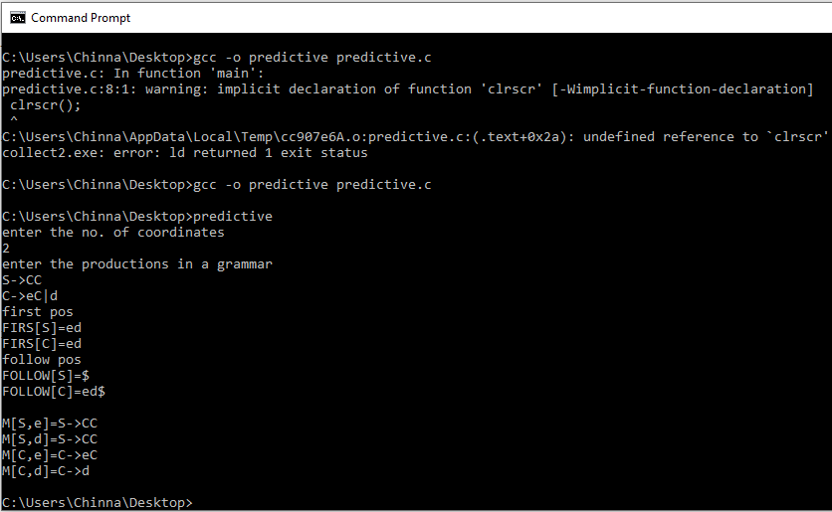

RESULT:

Thus the Program is executed and verified successfully.

EXP NO: 6 IMPLEMENTATION OF RECURSIVE DESCENT PARSER USING C
AIM:
To implement Recursive Descent Parser using C
ALGORITHM:
STEP 1: Read the input string.
STEP 2: Write procedures for the non terminals
STEP 3: verify the next token equals to non terminals if it satisfies match the non terminal.
STEP 4: If the input string does not match print error.
PROGRAM:
#include<stdio.h>
#include<ctype.h>
#include<string.h>
void Tprime();
void Eprime();
void E();
void check();
void T();
char expression[10];
int count, flag;
int main()
{
count = 0;
flag = 0;
printf("\nEnter an Algebraic Expression:\t");
scanf("%s", expression);
E();
if((strlen(expression) == count) && (flag == 0))
{
printf("\nThe Expression %s is Valid\n", expression);
}
else
{
printf("\nThe Expression %s is Invalid\n", expression);
}
}

void E()
{
T();
Eprime();
}

void T()
{
check();
Tprime();
}
void Tprime()
{
if(expression[count] == '*')
{
count++;
check();
Tprime();
}
}
void check()
{
if(isalnum(expression[count]))
{
count++;
}
else if(expression[count] == '(')
{
count++;
E();
if(expression[count] == ')')
{
count++;
}
else
{
flag = 1;
}
}
else
{
flag = 1;
}
}
void Eprime()
{
if(expression[count] == '+')
{
count++;
T();
Eprime();
}
}

OUTPUT:

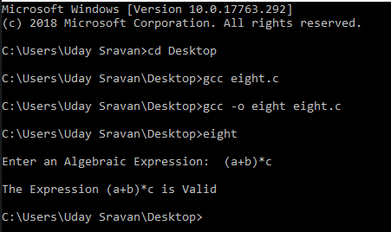

RESULT:

Thus the Program is executed and verified successfully.

EXP NO: 7 IMPLEMENTATION OF TYPE CHECKING

AIM
Write a program to implement type checking
ALGORITHM
STEP 1: If a variable is declared in the source program as an int in C the compiler will use 32-bits to store the representation of that variable.
STEP 2: If there is an assignment statement in the program of the form a = b; the compiler must ensure before code generation that both variables have either the same of compatible types.
STEP 3:In order to keep the project a reasonable size, you may make the following assumptions: In the programs to be type checked, there are three base types: void, int, and double.
STEP 4: In addition there are user-defined types using struct and union as well as pointer types to the base and user-defined types. To keep the implementation simple, you can assume that a single level of pointer types is allowed (although the grammar does not enforce it).
STEP 5: Types of basic constant expressions originate from constants (like 5, which has the type int, and 6.31 which has the type double), formal parameters (like x in void f(int x){…}), and variable declarations in the beginning of blocks (like {int x; double y;…}).
STEP 6: Types of simpler expressions are then propagated to more complex expressions (if the type of x and y is int then the type of x + y is also int).
STEP 7: There may be global variable declarations which will correspond to global storage allocation as describe in the second component of the project.
STEP 8:The expected type of an expression can be determined by (1) operator and the other sub expressions (for example, in x + y, x and y are expected to have the same type), (2) the type of the left-hand side in an assignment (in x=y, y is expected to have the same type as x), (3) the control statement where the expression occurs (the boolean guards in control statements is expected to have the type int), and (4) return types of functions (in int f(…){…return x;}, x is expected to have type int). The type checker should be able to handle sequences of statements, block-, if-, while- , assignment-, and return-statements; expressions containing constants, variables, (, ) , ~, -, +, *, /, , ++, --, ==,!=, <=, >=, && , ||. The boolean operators expect the operands to be of the same numeric type, either int or double, but never any user-defined type.
STEP 9: Pointer types for the purpose of Boolean operations, such as a nil comparison are to be treated as integer. In this simple language there are no type cast operators. The return type of a function can be void, which means that nothing should be returned and cannot be used as part of any expression.
STEP 10: A type violation or error occurs when the type of an expression is not the same as the expected type. A particular mild kind of type error occurs when a double is expected but an int is given. In this case a warning message shall be printed. For all other kinds of type errors, an error message shall be printed instead.
STEP 11: When a double is expected but an int is given, the type checker shall (internally and only for the purposes of the subsequent analysis) perform an automatic type cast from int to double.
STEP 12: When an error for which a warning is to be printed, after the warning is printed, the type checker continues, but for each expression, only the “innermost” and first detected warning shall be printed. For the more serious type errors, the type checker halts after the error message is printed.

PROGRAM
#include<stdio.h>
#include<stdlib.h>
int main()
{
int n,i,k,flag=0;
char vari[15],typ[15],b[15],c;
printf("Enter the number of variables:");
scanf(" %d",&n);
for(i=0;i<n;i++)
{
printf("Enter the variable[%d]:",i);
scanf(" %c",&vari[i]);
printf("Enter the variable-type[%d](float-f,int-i):",i);
scanf(" %c",&typ[i]);
if(typ[i]=='f')
flag=1;
}
printf("Enter the Expression(end with $):");
i=0;
getchar();
while((c=getchar())!='$')
{
b[i]=c;
i++;
}
k=i;
for(i=0;i<k;i++)
{
if(b[i]=='/')
{
flag=1;
break;
}
}
for(i=0;i<n;i++)
{
if(b[0]==vari[i])
{
if(flag==1)
{
if(typ[i]=='f')
{
printf("\nthe datatype is correctly defined..!\n");
break;
}
else
{
printf("Identifier %c must be a float type..!\n",vari[i]);
break;
}
}
else
{
printf("\nthe datatype is correctly defined..!\n");
break;
}
}
}
return 0;
}

OUTPUT:

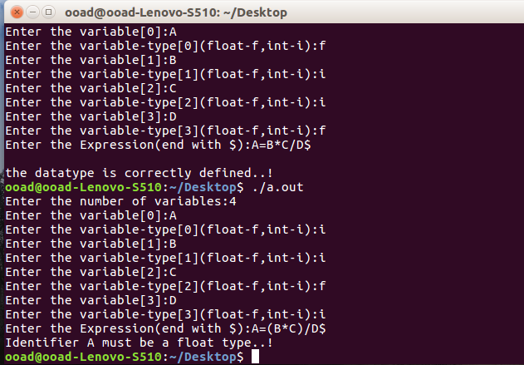

RESULT:

Thus the Program is executed and verified successfully.

EXP NO 8: CONSTRUCTION OF DAG
AIM
Write a program to construct DAG for an expression
ALGORITHM
STEP 1: Suppose the following three address statements: 1. x = y op z 2. x = op y 3. x = y
STEP 2: if(i <= 20) ... will be treated like case 1 with x undefined
STEP 3: If node(y) is undefined, create leaf labeled y, same for z if applicable
STEP 4: Find node n labeled op with children node(y) and node(z) if applicable.
STEP 5: When not found, create node n.
STEP 6: In case 3 let n be node(y) Make node(x) point to n and update the attached identifiers for x
PROGRAM
#include<stdio.h>
#define N 8
typedef struct node node;
struct node
{
int count;
node *next;
};
node graph[N];
void buildGraph(int a[][2],int edges)
{
int i;
for(i=0;i<N;++i)
{
graph[i].count=0;
graph[i].next=NULL;
}
for(i=0;i<edges;++i)
{
node *ptr=(node *)malloc(sizeof(node));
ptr->count=a[i][1];
ptr->next=graph[a[i][0]].next;
graph[a[i][0]].next=ptr;
graph[a[i][1]].count++;
}
}
void printGraph()
{
int i;
node *ptr;
for(i=0;i<N;++i)
{
node *ptr;
printf("%d:pred=%d:connected to",i,graph[i].count);
for(ptr=graph[i].next;ptr;ptr=ptr->next)
printf("%d",ptr->count);
printf("\n");
}
}
void main()
{
int a[8][2],i,j;
printf("\n\nEnter the edges b/w nodes\n");
for(i=0;i<8;i++)
{
for(j=0;j<2;j++)
{
scanf("%d",&a[i][j]);
}
}
buildGraph(a,8);
printf("\nThe DAG for (a+b)*c+((a+b)+e):\n\n");
printGraph();
}

OUTPUT:

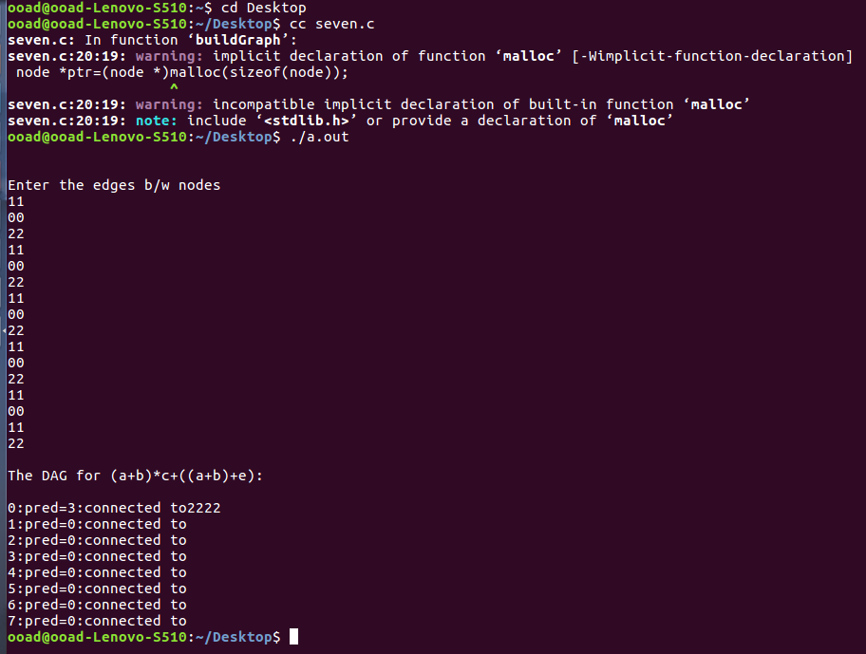

RESULT:

Thus the Program is executed and verified successfully.

EXP NO: 9 IMPLEMENTATION OF BACK END PROCESS OF COMPILER

AIM
To Write a Program to implement the Back End of a Compiler which takes the three address code and produces the 8086 assembly language instructions that can be assembled and run using a 8086 assembler.
ALGORITHM
STEP 1: Read the intermediate codes as input from the user.
STEP 2: Read and check each and every intermediate code in order to find the operator involved in it.
STEP 3: Based on the operator, we can print the mnemonics names for assembly code instruction. i.e, if the operator involved is ‘+’ then we can print the equivalent mnemonic name as ADD.
STEP 4: Similarly do steps 2 & 3 for all the intermediate codes given.
STEP 5: END.
PROGRAM
#include<stdlib.h>
#include<stdio.h>
#include<string.h>
#include<ctype.h>
void forswitch(char,int);
void conv(int);
char arg[10][10],op[5][2],ch[10],go[3][3],c[10];
void main()
{
int i=-1,m=0,k=10;
printf("\t\t\tTHREE ADDRESS CODE\n");
printf("OPERATOR\n");
printf("ARGUMENT-1\n");
printf("ARGUMENT-2\n");
printf("GOTO\n");
printf("~~~~~~~~~~~~~~~~~~~~~~~~~~\n");
do
{
i++;
printf("[%d]",i);
scanf("%s",op[i]);
forswitch(op[i][0],i);
scanf("%s",arg[m+i]);
scanf("%s",arg[m+1+i]);
scanf("%s",go[i]);
conv(m+i);
conv(m+1+i);
k++;
m++;
}while(i!=3);
printf("ASSEMBLY LANGUAGE CODE");
printf("\n\n100\tMOV %s,RO",arg[0]);
printf("\n101\tMOV %s,R1",arg[1]);
printf("\n102\tCMP R0,R1");
printf("\n103\t%s 107",ch);
printf("\n104\tMOV%s,R2",arg[3]);
printf("\n105\tMOV R2,%s",arg[2]);
printf("\n106\tJUMP 109");
printf("\n107\tMOV %s,R2",arg[5]);
printf("\n109\tend");
}
void conv(int x)
{
if(isdigit(arg[x][0]))
{
strcpy(c,"#");
strcat(c,arg[x]);
strcpy(arg[x],c);
}
}
void forswitch(char sh,int t)
{
if(t<1)
switch(sh)
{
case '<':
strcpy(ch,"JC");
break;
case '>':
strcpy(ch,"JNC");
break;
case '=':
strcpy(ch,"JZ");
break;
case '-':
break;
default:
printf("\n\t\tINVALID ENTRY");
}
}

OUTPUT:

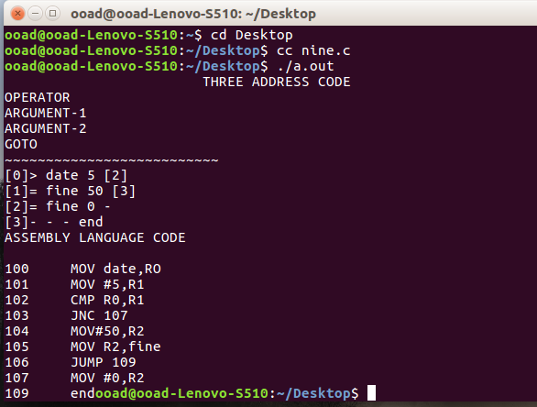

RESULT:

Thus the Program is executed and verified successfully.

EXP NO:10 IMPLEMENTATION OF CODE OPTIMIZATION TECHNIQUES
AIM
To write a program for implementation of Simple Code Optimization Techniques (Constant Folding., etc.)
ALGORITHM
STEP 1: Generate the program for factorial program using for and do-while loop to specify optimization technique and with constant variable j.
STEP 2: In for loop variable initialization is activated first and the condition is checked next. If the condition is true the corresponding statements are executed and specified increment / decrement operation is performed.
STEP 3: The ‘for’ loop operation is activated till the condition failure.
STEP 4: In do-while loop the variable is initialized and the statements are executed then the condition checking and increment / decrement operation is performed.
STEP 5: When comparing both for and do-while loop for optimization do while is best because first the statement execution is done then only the condition is checked. So, during the statement execution itself we can find the inconvenience of the result and no need to wait for the specified condition result. When compared with variable constant assigning can be done outside the Loop.
STEP 6: Finally when considering Code Optimization in loop do-while is best with respect to performance.
PROGRAM
Before Optimization:
#include<stdio.h>
int main()
{
int i, n;
int fact=1;
printf("\nEnter a number: ");
scanf(“%d”,&n);
for(i=n ; i>=1 ; i--)
fact = fact * i;
printf("The factoral value is: %d”,fact);
return 0;
}
After optimization:
Using do-while:
#include<stdio.h>
void main()
{
int n,f;
f=1;
printf("Enter the number:\n");
scanf(“%d”,&n);
do
{
f=f*n;
n--;
}while(n>0);
printf(“\nThe factorial value is:%d",f);
}

OUTPUT:

BEFORE OPTIMIZATION:
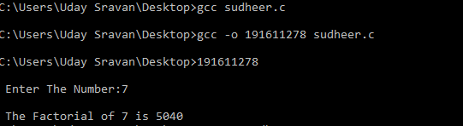

AFTER OPTIMIZATION:

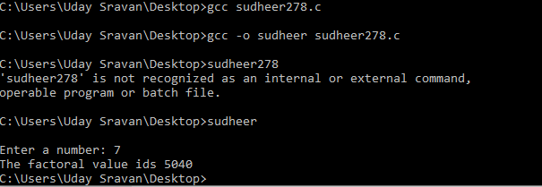

RESULT:

Thus the Program is executed and verified successfully.

EX.NO.11: IMPLEMENTATION OF SHIFT REDUCE PARSER

AIM:
To write a program to implement Shift reduce parser.

ALGORITHM:
STEP 1: Read the given Grammar, productions and the string to be parsed
STEP 2: Read each character of the string from left to right and compare it with the
Right hand side of each of the productions
STEP 3: If any match is found, replace the string with the corresponding left hand side of the production.
STEP 4: repeat step 2 and 3 until the string is reduced to the symbol of the grammar.
STEP 5: Stop

PROGRAM:
#include"stdio.h"
#include"stdlib.h"
#include"conio.h"
#include"string.h"
char ip_sym[15],stack[15];
int ip_ptr=0,st_ptr=0,len,i;
char temp[2],temp2[2];
char act[15];
void check();
void main() {
printf("\n\t\t SHIFT REDUCE PARSER\n");
printf("\n GRAMMER\n");
printf("\n E->E+E\n E->E/E");
printf("\n E->E*E\n E->a/b");
printf("\n enter the input symbol:\t");
gets(ip_sym);
printf("\n\t stack implementation table");
printf("\n stack\t\t input symbol\t\t action");
printf("\n______\t\t ____________\t\t ______\n");
printf("\n $\t\t%s$\t\t\t--",ip_sym);
strcpy(act,"shift ");
temp[0]=ip_sym[ip_ptr];
temp[1]='\0';
strcat(act,temp);
len=strlen(ip_sym);
for(i=0;i<=len-1;i++) {
stack[st_ptr]=ip_sym[ip_ptr];
stack[st_ptr+1]='\0';
ip_sym[ip_ptr]=' ';
ip_ptr++;
printf("\n $%s\t\t%s$\t\t\t%s",stack,ip_sym,act);
strcpy(act,"shift ");
temp[0]=ip_sym[ip_ptr];
temp[1]='\0';
strcat(act,temp);
check();
st_ptr++;
}
st_ptr++;
check();
}
void check() {
int flag=0;
temp2[0]=stack[st_ptr];
temp2[1]='\0';
if((!strcmpi(temp2,"a"))||(!strcmpi(temp2,"b"))) {
stack[st_ptr]='E';
if(!strcmpi(temp2,"a"))
printf("\n $%s\t\t%s$\t\t\tE->a",stack, ip_sym);
else
printf("\n $%s\t\t%s$\t\t\tE->b",stack,ip_sym);
flag=1;
}
if((!strcmpi(temp2,"+"))||(strcmpi(temp2,"*"))||(!strcmpi(temp2,"/"))) {
flag=1;
}
if((!strcmpi(stack,"E+E"))||(!strcmpi(stack,"E\E"))||(!strcmpi(stack,"E*E"))) {
strcpy(stack,"E");
st_ptr=0;
if(!strcmpi(stack,"E+E"))
printf("\n $%s\t\t%s$\t\t\tE->E+E",stack,ip_sym);
else
if(!strcmpi(stack,"E\E"))
printf("\n $%s\t\t %s$\t\t\tE->E\E",stack,ip_sym);
else
printf("\n $%s\t\t%s$\t\t\tE->E*E",stack,ip_sym);
flag=1;
}

if(!strcmpi(stack,"E")&&ip_ptr==len) {
printf("\n $%s\t\t%s$\t\t\tACCEPT",stack,ip_sym);
getch();
exit(0);
}
if(flag==0) {
printf("\n%s\t\t\t%s\t\t reject",stack,ip_sym);
exit(0);
}
return;
}
OUTPUT:
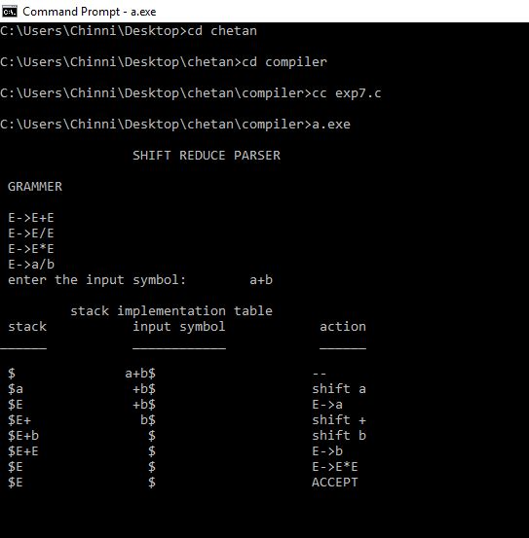
EX NO: 12 : IMPLEMENT THE FRONT END OF A COMPILER

AIM:
To Write a Program to implement the Front End of a Compiler.

ALGORITHM:
STEP 1: Read the input expression from the user using gets() function.
STEP 2: Read and check each and every character of the given input inorder to find the
highest precedence operator.
STEP 3: After finding the highest precedence operator, assign the sub expression
involved on
that operator on to a temporary name and print it.
STEP 4: Similarly find the next highest precedence operator and do Step 3 until ‘\0’
reched.
STEP 5: END.

PROGRAM:
//Program to implement the Front end of a Compiler
#include<stdio.h>
#include<conio.h>
#include<ctype.h>
#include<string.h>
char expr[100];
int tmpno=1;
int isopr(int prt)
{
char a=expr[prt];
if(a=='+'||a=='-'||a=='*'||a=='/'||
a=='('||a==')'||a=='='||a=='\0')
return 1;
else
return 0;
}
void compute(int start, int end)
{
int ptr,oprpos,stpos,endpos,i,j,blen,nlen,p;
char buff[100]="\0",cno[5],opr[]={'*','/','-','+'};
for(p=0;p<4;p++)
{
for(ptr=start;ptr<=end;ptr++)
{
if(expr[ptr]==opr[p])
{
oprpos=ptr;
ptr--;
while(!isopr(ptr)) ptr--;
stpos=ptr+1;
ptr=oprpos;
ptr++;
while(!isopr(ptr)) ptr++;
endpos=ptr-1;
printf("\nt%d = ",tmpno);
57
for(i=stpos;i<=endpos;i++)
printf("%c",expr[i]);
if(expr[stpos-1]=='(' && expr[endpos+1]==')')
{
stpos--;
endpos++;
end=start;
}
strncat(buff,expr,stpos);
buff[stpos]='t';
buff[stpos+1]='\0';
itoa(tmpno,cno,10);
strcat(buff,cno);
blen=strlen(buff);
nlen=strlen(expr);
for(i=blen,j=endpos+1;j<nlen;i++,j++)
buff[i]=expr[j];
buff[i]='\0';
blen=strlen(buff);
if(end!=start) end-=(nlen-blen);
strcpy(expr,buff);
tmpno++;
ptr=start;
}
}
}
}
void main()
{
int expptr,explen,close,open,i;
clrscr();
printf("Enter the Expression\n");
gets(expr);
for(expptr=0;expr[expptr]!='\0';expptr++)
{
58
if(expr[expptr]==')')
{
close=expptr;
while(expptr!=0)
{
expptr--;
if(expr[expptr]=='(')
{
open=expptr;
compute(open,close);
break;
}
}
}
}
expptr=0;
while(expr[expptr]!='=')
expptr++;
expptr++;
explen=strlen(expr);
compute(expptr,explen-1);
printf("\n%s",expr);
getch();
}
SAMPLE INPUT & OUTPUT
Input:
Enter the Expression
a = a + ( 3 - ( b – 2 ) * 4 )
Output:
t1 = b – 2
t2 = t1 * 4
t3 = 3 – t2
t4 = a + t3
a = t4

